
H. HARDCASTLE SCHOOL

Challenging the Future
Principal: Roberta Moriarty
Vice Principal: Trevor Gateley

February 2026

Webpage: http://www.edline.net/pages/hardcastle Twitter: @HHS_Royals Facebook: www.facebook.com/H.HardcastleSchool

Bows & Bouquets
- Thank you to Corrine Nedelec for donating cookbooks. These will be put to good use in the Home Ec. lab.
- Thank you to Connie Pollard for the generous donation of Lego blocks. Our students will enjoy these for many years to come.

Principal’s Message
Welcome to Term Two.

As we turn the page onto term two of the 2025-2026 school year, we are excited with the new changes to come. We would like to extend our best wishes to Mrs. Deobald on her retirement at the end of the term. Mrs. D. was an important member of our school community who always put student success above all else. Thank you for your time dedicated to our school and enjoy all the new and exciting things that will come your way. Don’t be a stranger, we look forward to having you come back soon to sub.

We would like to welcome Mr. Lee Bells to our school community. He brings a plethora of knowledge, skills, and ideas on how to support our students. If you see a new face in the school and community, please extend a warm welcome to Mr. Bells.

With the new term comes new classes, new schedules, new teachers, new extracurricular and a new school season. February is a time of “new” in our school calendar, and we welcome the change for staff, students, and our families.

Sincerely,

Mrs. Roberta Moriarty
Happy Retirement

Congratulations to Mrs. Deobald on her retirement at the end of January. After many years of service to our students, our school and our community, this is a well-deserved honour. Thank you for your time, dedication to excellence, and thousands of hours in the gym coaching students. Enjoy this time with your family, and we hope to see you back in the halls subbing soon! If you see Mrs. D in the hallways or the community, please pass on your congratulations and a heartfelt thank you. We will miss you, Mrs. D!

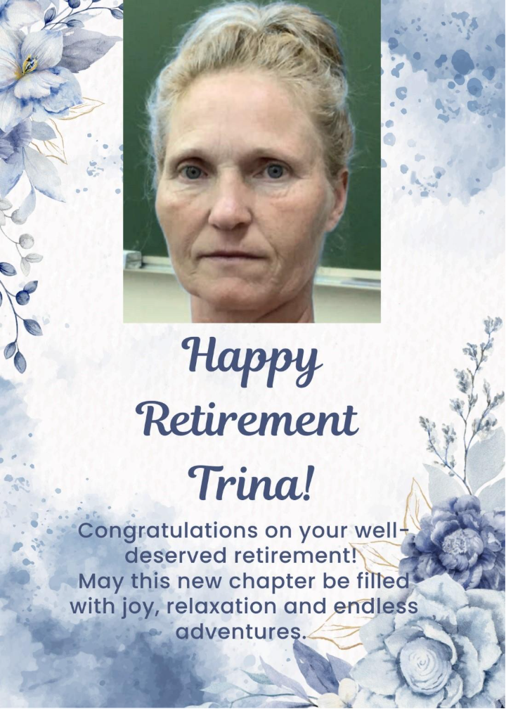

A New Face
Please welcome Mr. Lee Bells to our school! Mr. Bells has joined us this term to teach ELA, Information Processing, Social, PAA, and Health. We hope you’ll say hello and help make his first days a great start.

Babysitter’s Course
The Grade 7 Home Economics Class has successfully completed the Babysitting Course offered by the Saskatchewan Safety Council. As part of their training, students engaged in a practical experience, providing babysitting services for a few hours. They concluded their course with “Little Buddy Day”, during which students brought preschoolers to the school and organized various games and activities for them.
We are pleased to offer a new cohort of qualified, skilled, and responsible babysitters to the Edam community.
Report Cards
Report Cards will be available on Edsby in the afternoon on Friday, February 6th. You can conveniently access your child’s report card online.
If you prefer a printed copy, please let the office know and a printed copy will be distributed the week of February 9th – 13th.
Staff & Teacher Appreciation Week
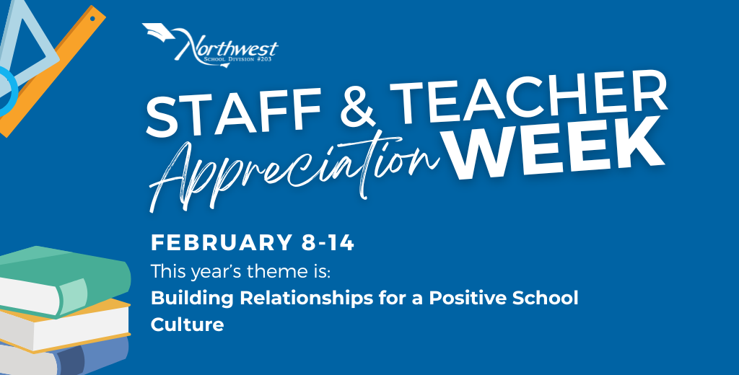
Help us celebrate Staff and Teacher Appreciation Week! HHS is full of incredible people who support, teach, coach, encourage and care for students every single day.
Visit Edsby via the River of News to share a positive message to recognize our amazing staff. Your kind words will be shared on social media throughout Staff Appreciation Week.

Family Literacy Bingo
To celebrate Family Literacy Week in Saskatchewan, we are inviting families to participate in a Family Literacy Bingo. Literacy is much more than reading books; it includes the everyday skills we use to understand information, communicate ideas, and solve problems.
This Bingo sheet encourages simple, fun activities that families can do together at home to build these important skills. This Bingo challenge highlights some of the many ways that literacy is part of our daily lives and celebrates the important role families play to support learning.
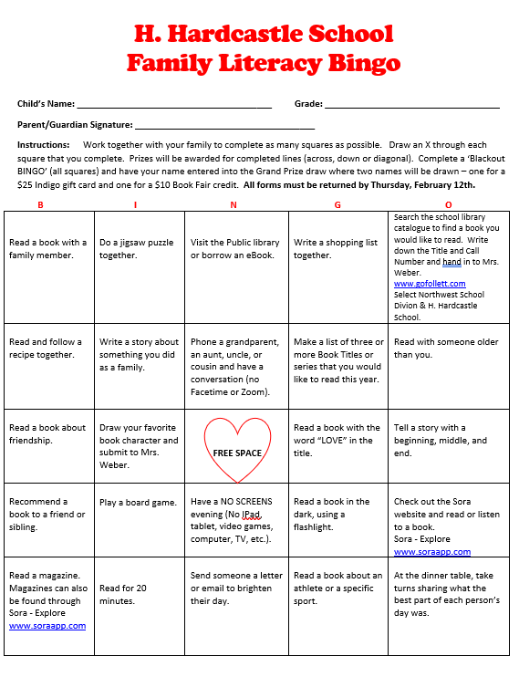


February 2026
Sunday | Monday | Tuesday | Wednesday | Thursday | Friday | Saturday
1 | 2 Day 3 | 3 Day 4 K  Soup Lunch  $5/bowl | 4 Day 5 | 5 Day 6 K | 6 Day 1  Hat Day for Telemiracle  Report Cards Published on Edsby | 7
8 | 9 Day 2 K  100th Day of School  SCC 100th Day of School Lunch | 10 Day 3  Culture Camp  Soup Lunch  $5/bowl | 11 Day 4 K  Hot Dog Lunch | 12 Day 5  Literacy Bingo Forms Due | 13 Day 6 K  Hat Day for Telemiracle | 14
15 | 16 | 17  N O | 18  SCHOOL | 19 | 20 | 21
22 | 23 Day 1 | 24 Day 2 K  No Soup | 25 Day 3  Pink Shirt Day  Dwayne Peace Presentation Gr. 4-6 | 26 Day 4 K | 27 Day 5  School Wide Breakfast  Hat Day for Telemiracle | 28

